**TERRAFORM TASK2**

Created one random ID

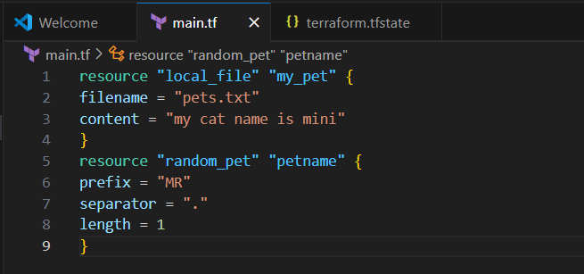

Here, we have added local file and also with random ID

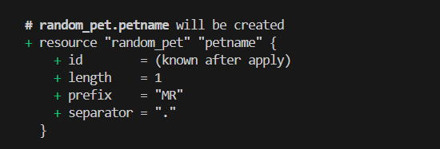

Terraform apply

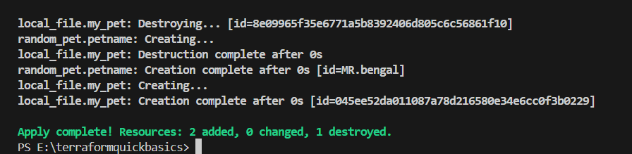

Changing the name in resource in content – localfile

Here I have forcely replaced the name of content local file

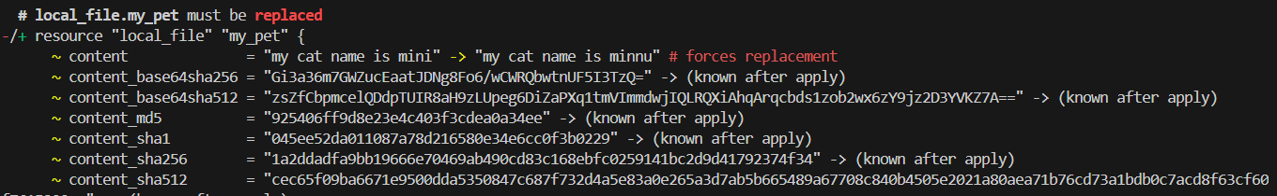

Terraform added 1 & Terraform destroy 1

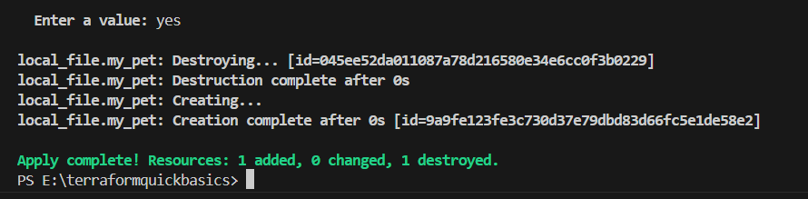

Integrate terraform in jenkins using Terraform plugin.

Downloaded the terraform in ec2service and unzip

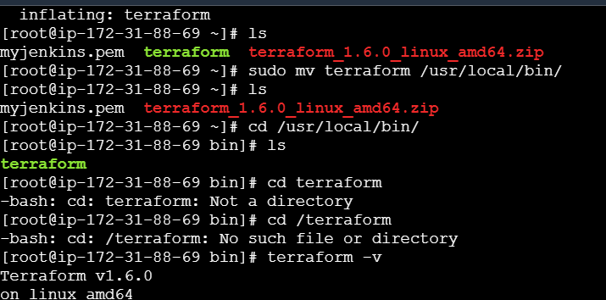

Created a job and given this script in execute shell

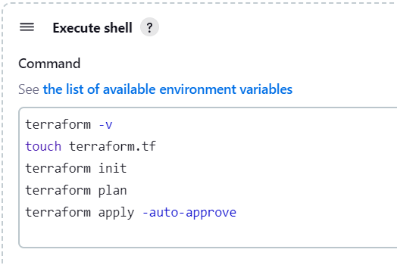

Here, is the output of Jenkins job with terraform plugin and got success output

